|  |  |  |
| --- | --- | --- |
| विकसित_इंडिया_new-removebg-preview.png  ***Development of Biodegradable Molded Sheets of Deoiled Rice Bran (DRB) Through Extrusion Technique***  *Tanuja Srivastava 1\*, Suhail Ahmad Bhat 1, Swati Priyadarshi 1, Noopur Khare 1*  *1 Bhai Gurdas Institute of Engineering and Technology, Sangrur, Punjab, India*  *2 Sant Longowal Institutes of Engineering and Technology, Longowal, Sangrur, Punjab, India* | *Viksit India*  ***2023 | Volume: 01 | Issue: 01| Page:1-11*** |  |

|  |  |
| --- | --- |
|  | |
| **Article Info**  Received: June 8, 2023 Revised: August 16, 2023  Published: November 1, 2023 Editor: Dr. Neelesh Kumar  **\*Corresponding author**  Email: [tanusriva@yahoo.co.in](mailto:tanusriva@yahoo.co.in)  9458608149  **Open Access**  **DOI:**  This is an Open Access article distributed under the terms of the Creative Commons Attribution License (http://creativecommons.org/licenses/by/4.0/), which permits unrestricted use, distribution, and reproduction in any medium, provided the original work is properly cited.  **Viksit India n 2.png**  **https://vi.rase.co.in/**  **ISSN: 2278-1757**  **Copyright** **© DHE** | **Abstract**  "Today's primary owners are searching for environmentally friendly solutions that may differentiate them from the competition while also being cost- and production-effective. It is necessary to build a biodegradable, environmentally friendly, medium water-resistant composite from protein-based by-products of grain processing for agricultural planting applications in an effort to move away from ecologically harmful plastics and other polymers. After oil has been extracted from rice bran using a solvent extraction process, the resulting deoiled rice bran (DRB) is a good source of protein (18–23%). The current research is a step towards creating deoiled rice bran (DRB)-based material that is both environmentally friendly and moderately water-resistant. Using a twin-screw extruder and a hydraulic press molding machine, molded sheets were created using a combination of sawdust, deoiled rice bran (used as a polymer), and different concentrations of glycerol (used as a plasticizer). Because of its better texture, medium water resistance capacity, and eco-friendliness, the most significant combination was found to be superior at a G/P ratio of 0.4 compared to others (0, 0.3, 0.6, and 0.7). It also completely deteriorated in 45 days after being planted in the soil. In the future, moldable sheets made of this biodegradable material could be utilized as planting containers in agriculture."  **Keywords:** Biodegradation, De-oiled rice bran, Twin screw extruder, Hydraulic press molding machine, Planting containers.  **Introduction**  "In recent years, there has been a lot of anticipation and enthusiasm surrounding the science and technology of biodegradable materials. Chemical science and technology deal with the synthesis, assembly, and production of products that have advanced significantly and are equally important. Major advancements in the creation, characterization, and application of chemical science and technology assemblies are anticipated in the upcoming ten years. The discovery and commercialization of biodegradable materials will also advance further in the current scenario. The chemical, energy, electronics, and space industries are all destined to be impacted by these emerging technologies. They will also be used in the fields of medicine and healthcare. In the era of chemical science and technology, rice plays an important role not only in food but also in preparing rice bran biodegradable molded sheets (Hernández-Barco et al., 2021).  The cereal food rice is a staple and an essential part of many people's diets all across the world. Oryza sativa and Oryza glaberrima, two species of food plants in the Poaceae ("true grass") family, are examples of domesticated rice. The sticky, short-grained japonica or sinica variant of Oryza sativa and the non-sticky, long-grained indica version are the two main subspecies. Japonica is often produced in dry fields in temperate East Asia, upland Southeast Asia, and high elevations in South Asia, while indica is primarily lowland rice that is planted mostly submerged across tropical Asia (Hilbert et al., 2017).  Rice is the second-most consumed cereal grain and is a staple food for a significant portion of the global population, particularly in tropical Latin America and East, South, and Southeast Asia. Rice has the ability to enhance food security, promote rural development, and assist in environmentally friendly land management (Phalan et al., 2013). More than a quarter of the calories we consume come from rice. Due to concerns about a global rice shortage, some governments and businesses started limiting supplies of the grain in early 2008 (Ben Hassen et al., 2022)." Brown rice is milled because white rice is typically preferred by consumers due to its appearance. The milling process produces rice bran, a significant byproduct that is high in fiber, proteins, lipids, and significant antioxidants such as vitamin E and gamma-oryzanol. Deoiled rice bran, which is produced after oil extraction, is rich in proteins and amino acids (Huang et al., 2021). |

In general, alkali or acid hydrolysis, followed by acid precipitation, can be used to extract the proteins and amino acids contained in deoiled rice bran. About 8% of brown rice is made up of rice bran. Despite being high in fat (13%) and protein (12–18%), rice bran is still underutilized as a dietary ingredient (Borresen et al., 2014). There is an estimated 27.3 million tons of rice bran that could be produced worldwide. Producing biodegradable packaging materials and using them as planting containers in agriculture are all possible uses for it. Retail buyers and customers are pressuring growers to provide more environmentally friendly and sustainable goods and services. Nursery owners are searching for environmentally friendly options that can differentiate them from the competition while also being affordable and productive. Primary providers have looked for a wide range of materials to manufacture biodegradable, eco-friendly packaging in an effort to move away from environmentally harmful plastics and other materials (Markevičiūtė et al., 2022). The majority of artificial biodegradable polymers are too expensive for widespread use. The poor water resistance of starch-based polymers also places restrictions on their use. A novel type of inexpensive, biodegradable, and moderately water-resistant composite made from maize protein was described by Tabasum (Tabasum et al., 2019). Additionally, they demonstrated how biodegradable maize gluten meal (CGM) materials are currently being developed. This material made it easier to evaluate the biodegradability of injection-molded items such as pots used as planting containers for agricultural crops and to reduce the amount of glycerol in the composite to lower the material cost.

The proposed work aims to utilize the application of chemical science and technology in the development of biodegradable molded sheets of deoiled rice bran (DRB) through extrusion technique. Deoiled rice bran (DRB) can be used to create these biodegradable molded sheets, which can then be used as planting containers. A twin-screw extruder and hydraulic press molding equipment would be used to create a low-cost biodegradable and moderately water-resistant composite sheet.

**Material and Methods**

**Selection and procurement of materials**

Deoiled rice bran, which contains a high amount of protein and is useful for binding with other components like sawdust and glycerol, was generously provided for use in this study by M/s. AP Solvex Ltd., Dhuri, Punjab. The investigation only employed analytical-grade reagents. Higher molecular weight alcohols such as polyols and glycerol, as well as other suitable plasticizing agents, are useful in the current composition. The Mechanical Engineering Workshop at BGIET, Sangrur, provided the sawdust.

**Chemical Composition of DRB**

**Moisture content**

A precisely weighed sample was taken in a moisture cup that had already been dried and weighed. The moisture cup and sample were placed in the oven, which was kept at 106°C, for 4–5 hours. Drying, cooling, and weighing procedures were repeated every 35 minutes until the difference between successive weights was less than 1mg. After that, it was moved into desiccators and chilled. It was then weighed. The following formula was used to determine the moisture content percentage:

*Moisture content% = 100(W2-w) / (W1-w)*

Where;

W = weight of empty petri plate;

W1 = Weight of petri plate with sample before drying;

W2 = Weight of petri plate with sample after drying to constant weight.

**Ash content**

A precisely weighed sample was added to a crucible that had already been dried and weighed. The sample-filled crucible was slowly heated on a flame to achieve complete charring, and then heated in a muffle furnace for 5–6 hours at 555–11°C to produce ash. Then it was weighed after cooling in desiccators. The amount of ash in percent was determined as

*Total ash% = 100(W2-w) / (W1-w)*

Where;

W = weight of empty dish;

W1 = Weight of dish with sample;

W2 = Weight of dish with ash.

**Oil content**

A sample of 6 gm was placed on filter paper, and 26 ml of petroleum ether was then added. After 4 hours in the extraction assembly, the oil content (%) was calculated using the following formula:

*Oil content% = w2 X 100 / w1*

Where,

W1 = Mass of sample

W2 = Mass of oil

**Protein content (Kjeldahl method)**

On the basis of the quantity of reduced nitrogen (NH2 and NH) that could be found in the sample, the nitrogen content was determined using the Kjeldahl method (Stevenson, 1983). Ammonium sulphate was produced by heating several nitrogenous compounds with concentrated H₂SO4. The ammonium sulphate that had been generated was broken down with an alkali (NaOH), and the released ammonia was absorbed in excess of a neutral boric acid solution before being titrated with standard acid. A digestion flask containing a 1:5 mixture of copper and potassium sulphates was filled with a 2 gm sample before 26 ml of concentrated H2SO4 was added. 5-6 hours were allowed for digestion before a clear solution was obtained. The resulting solution was then distilled with 5 % boric acid and 21% NaOH after cooling. By adding 8-9 drops of mixed indicator (bromocresol green and methyl red solution, in a 6:2 ratio), it was titrated against 0.01N HCl solution. The formula above was used to determine the protein content,

*Nitrogen %=( T2-T1) x NHCl x 14 x V x 100/D x W x 1000*

Where;

T2= Sample titre

T1= Blank titre

NHCl= Normality of HCl.

V= Volume made up of the digest.

D= Aliquot of the digest taken

W= Weight of sample taken

*Protein% = Nitrogen% X 6.25*

**Crude fibre**

A food sample is processed under controlled conditions with petroleum spirit, boiling sodium hydroxide solution, diluted sulphuric acid, and alcohol to leave behind an organic residue known as crude fibre. With the help of petroleum ether or another organic solvent, 3 gm of dry material was extracted. The residue from the extraction process was placed to a digestion flask together with 0.6 gram of asbestos and 300 ml of the boiling sulfuric acid. Following their addition, the digesting flask was heated and attached to a condenser. It took 40 minutes to boil. Once it had boiled, the flask was taken out and the residual mixture had been filtered through linen using a fluted funnel. 300ml of boiling NaOH solution was used to wash the residue from acid digestion back into the flask after the NaOH solution had been heated to boiling under a reflux condenser. This was attached to the reflux condenser-equipped flask and boiled for 40 minutes. Following 40 minutes of boiling, the flask was removed, and the remaining fluid was filtered using a fluted funnel and filtering cloth. The leftover mixture was washed with water and then filtered through a potassium sulphate solution. The residue was removed from the crucible, chilled for 4–5 hours, and weighed.

*% crude fiber=loss in weight noted X (100/weight of sample taken)*

**Protein Extraction and Protein Solubility**

**Protein extraction**

The alkaline hydrolysis method was utilized in this investigation to extract protein from deoiled rice bran. This approach involved dissolving DRB (2 g in 10 ml of distilled water) to a solids concentration of roughly 30%. After that, a 0.2M sodium hydroxide solution was used to bring 5 ml of this suspension's pH up to 10. The alkali hydrolysis reaction took 55 minutes to complete at a temperature of 40 °C. The process was then stopped by bringing the pH of the suspension to neutral using a 0.3M hydrochloric acid (HCl) solution. After drying in an oven at 75°C, the leftover bran was removed from the soluble product with a vacuum filter using filter paper and weighed. Using this technique, protein is extracted from DRB and then characterized (Zhang et al., 2019).

**Protein solubility**

For the purpose of determining protein solubility at pH 4 to 8, 30 mg of protein sample was dispersed in 30 ml of deionized water, adjusted to pH 4 and similarly for other pH using 0.2 N HCl or 0.2 N NaOH, magnetically agitated at room temperature for 40 minutes, then centrifuged at 4000 x g for 30 minutes. Kjeldahl's protein estimation method was used to calculate the protein content (Jung et al., 2003).

*Protein solubility %=( protein content in supernant/protein content in sample) X 100*

**Extrusion Process for the Formulation of pellets**

The primary purpose of an extruder is to create enough pressure in the material to push it through the die. The shape of the die, the flow characteristics of the material, and the flow rate all affect the pressure required to force a material through the die. Extruders are utilized in most molding activities, including injection molding and blow molding, in addition to extrusion operations. One screw or more screws may be present in a screw extruder. Extruders with one screw are referred to as single screw extruders, and those with many screws are referred to as multi screw extruders. The twin screw extruder, which has two screws, is the most popular type of screw extruder. Twin screw extruders come in many different varieties. The screws in the majority of twin screw extruders are placed side by side. An extruder is referred to as a co-rotating twin screw extruder if both screws rotate in the same direction. A twin screw extruder is referred to as a counter rotating twin screw extruder if its screws rotate in the opposite direction preparing the feed before extrusion (Alemayehu, 2017). To produce it free-flowing, 200gms of DRB were combined with sawdust and varied glycerol concentrations in 30% water. Based on DRB and sawdust used for extrusion, the amount of glycerol in the feed ranged from 0 to 70%. Before being fed into the feed funnel, the material was checked many times to ensure correct mixing and stored for at least 40 minutes to ensure proper conditioning.

**Pre-conditioning**

After being held in a warm, moist, mixing atmosphere for a certain amount of time, raw ingredients are released into the extruder. To ensure that the surface of the raw material particles come into contact with the additional steam and water, good mixing is necessary. It takes a long retention period to allow the processes of heat transfer and diffusion to move the moisture and energy from the particle's surface to its core. As a result, the steam and water in the pre-conditioner environment cause the raw material particles to become plasticized. Pre-conditioning's goal was to thoroughly plasticize the raw materials component parts in order to get rid of any dry core (Davis et al., 2018). Pre-conditioning has been shown to boost the throughput of the extrusion system in the area of extruder capacity, extending the life of wear components in the extruder barrel by a factor of three. Along with improving product flavor, it also helps to change the functionality and textures of products. This procedure is carried out 34 hours prior to the raw materials being put into the extruder to produce the desired result. This method involved adding water or any other organic substance to the raw material until the desired moisture content was reached. The raw materials were fed into the extruder for further processing after the desired moisture level was controlled with an appropriate amount of water, as given in Table 1. Extrusion cooking is a complex food processing procedure due to the physico-chemical changes, molecular rearrangements, and interactions between the parts of the food system. Numerous researchers have looked at various facets of low and moderate moisture extrusion. Wet extrusion is an emerging field of study (Osen et al., 2014).

Twin-screw extruders offer novel techniques to process high moisture extrudates with enhanced texture and potential taste modification. They have been used in nearly all wet extrusion-related research. A twin-screw extruder with a smooth barrel from the lab of Basic Technology Private Limited (BPTL) was utilized. To precisely adjust the rpm in accordance with process requirements, the drive system of the BPTL TS Extruder is equipped with a SIEMENS / ABB Frequency Converter. Due to the gradual torque generation of this sort of drive, a bypass switch is given to allow for the direct application of the drive from the motor that provides the sudden application of torque required to clean the barrel of burnt-out goods. It is crucial to give moisture, say 20% moisture, to the meal. Following initial mixing, the water must be run three to four times through the given screen before being retained in a container and manually pushed to achieve conditioning. 5 g/min was used as the continuous feed rate for the extruder. The moisture level was fixed at 32%, and the screw speeds were 300 rpm.

The extruder's horizontal split design allowed samples to be collected inside the extruder channel during a "dead-stop run." The extruder was abruptly terminated by stopping the feed supply, the screw rotation, and the electrical heating when it reached a steady state, as evidenced by the steady values of the screw torque and die pressure.

The refrigeration system swiftly cooled the barrel to the heating sections' ambient temperature before disassembling it. Samples were collected along the channel of the extruder. Although the dead-stop procedure took a long time, it only took 40 seconds for the barrel to cool down to below 90°C, the temperature at which the reaction practically comes to an end. A long barrel extruder of 35 to 40 L/D is required for a single-stage extrusion, with a cooking zone for the melting process close to the feed input and a cooling area following. Before being extruded, the fluid must first be chilled to -150°C and the polymers must be melted in the first portion. It was crucial that the extrudates of the half-product, as depicted in the picture, were free of any air bubbles. By creating significant cavities, these would cause distortions in the snack during growth. When the cooking and chilling processes are combined, it is more difficult to regulate them, which typically results in a lower throughput on the machine used for the single-stage extrusion process.

**Hydraulic Press for the Development of molded Sheets**

Power may be given to hydraulic presses, or a set of the hydraulic press was primarily utilised in industries where thin metal sheets needed to be compressed under strong pressure. The material needed to be worked on was crushed or punched into a thin sheet using an industrial hydraulic press and press plates. Almost all industrial tasks required the use of a hydraulic press. But in essence, it was employed to convert metallic items into metal sheets. It was employed in other fields to thin glass, produce powders for the cosmetics sector, and create tablets for medical usage. In order to create the correct shape and size, the compounds that had been maintained on top of the dies were allowed to melt down. The water inflow knob was turned, allowing the dies to cool. Molded samples were taken out after the die set was removed.

**Table 1:** Moisture content in Deoiled Rice Bran with varying percentage of glycerol

|  |  |  |
| --- | --- | --- |
| **Sr. No.** | **Deoiled Rice Bran (DRB) Samples** | **Moisture content (%)** |
| 1 | DRB | 14.09 |
| 2 | DRB + Saw dust + (0%) glycerol | 20.45 |
| 3 | DRB + Saw dust + (15%) glycerol | 31.33 |
| 4 | DRB + Saw dust + (35%) glycerol | 31.24 |
| 5 | DRB + Saw dust + (45%) glycerol | 20.85 |
| 6 | DRB + Saw dust + (55%) glycerol | 29.02 |

**Physico-Chemical Characteristics of Molded Sheets**

**Water holding capacity (WHC)**

The Yamazaki method, as modified by Moghal (2020), was used to calculate WHC. 6 gm DRB molded sheets (dry weight) were suspended in 85 ml of distilled water, stirred for an hour, and then centrifuged at 4000xg for 20 min. The wet DRB was drained for 20 minutes after the free water was taken out of it. After that, the wet DRB molded sheets were weighed.

*WHC %=Weight of residual DRB sample / weight of sample X 100*

**Solubility index**

The solubility of a DRB-molded sheet (0.7 gm d/b) was evaluated by heating it to 70 °C for 40 minutes while stirring to prevent lump formation. The mixture was centrifuged at pressures that had a single line of operation. At 4000 rpm for 25 minutes, a hydraulic pump delivers the required amount of water or oil. An accumulator keeps a reserve large enough to support all presses on the line without weighing, and the supernatant was carefully pressed to the desired pressure. The swelled DRB molded sheet sediment pressure fluctuation was placed in pre-weighed petri dishes after an aliquot of the supernatant (10 ml) was obtained. The amount of DRB-molded sheet that was soluble in water was reflected by the residue that was left over after drying the supernatant. As a measure of solubility,

*Solubility %= weight of soluble material / weight of sample X 100*

**Rheological Characteristics of DRB molded Sheets**

A texture analyzer was used to measure the hardness of biodegradable sheets. The time duration of the force activity is represented by the shape of the curve on the instrument, and the complete procedure of deformation, compression, cutting, or kneading was observed. Texture profile analysis has been done using the following settings:

* Mode: Measure Force in Compression
* Test speed: 6.0 mm/s
* Post-test speed: 3.0 mm/s
* Distance: 7 mm
* Data acquisition rate: 300 pps
* Temperature: ambient (28°C)

Feed moisture content has a positive effect on extrudate hardness, and screw speed and temperature have negative effects. Feed moisture content was found to have the most significant effect on extrudate hardness. Feed rate has no significant effect. The compression was repeated twice to generate a force-time curve from which hardness (the height of the first peak) was determined.

**Table 2**: Chemical Composition of Deoiled Rice Bran

|  |  |
| --- | --- |
| **Characteristics** | **Percentage** |
| Oil content | 1.41 |
| Moisture content | 12.08 |
| Ash content | 1.89 |
| Protein content | 18.97 |
| Free fatty acid (FFA) | 16.09 |
| Crude fibre | 11.54 |

**Table 3:** Effect of pH on protein solubility of Deoiled Rice Bran.

|  |  |  |
| --- | --- | --- |
| **Sr. No.** | **Samples** | **Protein solubility (%)** |
| 1 | DRB at pH 4 | 22.13 |
| 2 | DRB at pH 5 | 27.45 |
| 3 | DRB at pH 6 | 31.34 |
| 4 | DRB at pH 7 | 33.65 |
| 5 | DRB at pH 8 | 43.11 |

**Biodegradability test**

60 gm of molded sample was taken with different proportion of raw materials. Then a hollow square of11cmx12cmx13cm dimension has been prepared in ground and kept molded sheets inside it and covered with soil. This square was developed where sufficient amount of water available to molded sheet. The pH of soil was 5.6 and then its biodegradability test was determined on the basis of molded sheet weight loss after 20 days interval as per the method.

**Percentage weight loss in molded sheets**

Pre-weighed petri-plate was taken for weighing 60 gm of molded sheet for biodegradability test. After 20 days interval, molded sheets were weighed and weight loss was determined by using following formula:

Weight loss 9%0= final weight-intial weight / intial weight of the sample X 100

**Results and Discussion**

**Characterization of DRB**

Bran is particularly rich in dietary fiber and omega fatty acids and contains significant quantities of starch, protein, vitamins, and dietary minerals. DRB sample was rich in protein with good binding capacity. After analyzing DRB, different physico-chemical values were reported as in Table 2. It is clear that, DRB is rich in protein (19.6%) which is approximately similar as reported by showed good binding capacity for preparing molded sheets.

**Protein solubility index**

Protein solubility of DRB at different pH has been shown in Table 3. It has been observed that solubility of protein was proportional to pH of DRB solution i.e., as pH increased the protein solubility also increased. Solubility of protein was influenced by chemical composition of the buffer, ionic strength, temperature, and pH.

**Optimization of Parameters of Twin Screw Extruder**

**Feed rate of extruder**

As shown in Table 4, pellets formed at flow rate of 2 and 3 g/s, were not good in texture due to insufficient supply of DRB sample. Pellets of control sample (G/P ratio 0) at feed rate 4 and 5 g/s were of good texture which has been further used for preparation of molded sheets. Optimization of temperature and feed rate of extruder showed that for formulation of pellets 140 C temperature of barrel and feed rate of 5 g/s were suitable adjudged by the better texture than others.

**Temperature of extruder**

Screw speed- 300 rpm; feed moisture contents- 21.6, 20.5 and 19.4%, and feed rates- 1, 2, 3 and 4 g/s. were used for extrusion of samples. Barrel temperature zone profiles were set to 100, 110, 115, 120 and 130°C for formulation of the pellets. As shown in Table 5, the control sample at 100, 110 and 115 C temperatures showed unsatisfactory result because sample flowed in similar form through die as it was added in hopper of extruder. At 140 C temperature good textured pellets were formed, suitable for further operation of molding.

**Table 4:** Effect of feed rate on pellet formulation

|  |  |  |  |
| --- | --- | --- | --- |
| **Sr. No.** | **Samples** | **Feed rate (g/s)** | **Pellets obtained** |
| 1 | Control sample | 1 | Too slow |
| 2 | Control sample | 2 | Too slow |
| 3 | Control sample | 3 | Slow but product can obtained |
| 4 | Control sample | 4 | Good for pellet formulation |
| 5 | DRB with 0.2 G/P ratio | 5 | Satisfactory for pellet formulation |

**Table 5:** Effect of barrel temperature of extruder on pellet formulation

|  |  |  |  |
| --- | --- | --- | --- |
| **Sr. No.** | **Samples** | **Barrel Temperature (OC)** | **Pellets obtained** |
| 1 | Control sample | 111 | unsatisfactory |
| 2 | Control sample | 121 | unsatisfactory |
| 3 | Control sample | 126 | satisfactory |
| 4 | Control sample | 141 | satisfactory |
| 5 | DRB with 0.2 G/P ratio | 140 | satisfactory |

**Table 6:** Effect of molding time and temperature and glycerol concentration on formation of molded sheets

|  |  |  |  |  |
| --- | --- | --- | --- | --- |
| **Sr. No.** | **Samples with G/P ratio** | **Temperature (OC)** | **Time (min.)** | **Molded sheets** |
| 1 | Control sample | 140 | 20 | Break easily |
| 2 | Control sample | 140 | 30 | Break easily |
| 3 | Control sample | 150 | 30 | No hard texture |
| 4 | Control sample | 160 | 30 | Not get broken but have very poor texture |
| 5 | Control sample | 170 | 30 | Good texture |
| 6 | Control sample | 180 | 30 | Totally get burnt |
| 7 | 0.2 | 160 | 30 | Not get broken but have a poor texture |
| 8 | 0.2 | 170 | 30 | Good textured sheet obtained |
| 9 | 0.4 | 170 | 30 | Good textured sheet obtained |

**Optimization of parameters of hydraulic press**

Temperature of hydraulic press was optimized as given in Table 6. Molded sheets prepared at 150°C for 30 min in hydraulic press were got stick to the mold and fragile. Similar results were obtained at 150°C and 160°C for 40min. molded sheet of control sample prepared at 170 C for 40 min. did not stick to the surface of mold but had very poor texture. At 180 C for 40 min, molded sheet of control sample were showed good texture, not broken and stuck to the surface of mold at the time of removing. At 200 C, the molded sheet of control sample was completely burnt. For testing time-temperature combination for other samples with varying proportion of glycerol, were molded at 170 C for 40 min. Results of this arrangement showed that the molded sheets were formed but has very poor texture. Above observations showed that the suitable time and temperature for formulation of molded sheets from control sample, were 180 C and 40 min. and this time-temperature combination was used for other DRB samples with varying composition of glycerol.

**Physico-Chemical and Textural Properties of DRB Molded Sheets**

**Water holding capacity of molded sheets**

The present compositions were molded to provide solid articles of varying shapes, size and dimensions, that were useful in a variety of applications Advantageously products prepared with the DRB composition showed improved water resistance power as given in Table 7. The molded article can be used as a planting container the composition of the invention may be molded or extruded to provide foamed products such as packaging, loose fills, dishes and cups and the like. Residual water in the composition may be suitably used as a blowing agent. It was clear from the above-mentioned table that the water holding capacity decreased as the glycerol content increased. However, reported the range of water holding capacity from 70% giving better results than others for biodegradability as studied in their experiment.

**Table 7:** Effect of molding time and temperature, glycerol concentration on water holding capacity

|  |  |  |  |  |
| --- | --- | --- | --- | --- |
| **Sr. No.** | **Glycerol to Polymer ratio (G/P)** | **Molding Temp. (OC)** | **Molding Time (min.)** | **WHC (%)** |
| 1 | Control sample | 180 | 30 | 102.7 |
| 2 | Control sample | 180 | 40 | 100.31 |
| 3 | 0.3 | 170 | 40 | 89.91 |
| 4 | 0.3 | 180 | 40 | 74.01 |
| 5 | 0.5 | 180 | 40 | 63.91 |
| 6 | 0.6 | 180 | 40 | 43.91 |
| 7 | 0.7 | 180 | 40 | 29.31 |

**Table 8:** Effect of molding time and temperature, and glycerol concentration on solubility of molded sheets

|  |  |  |  |  |
| --- | --- | --- | --- | --- |
| **Sr. No.** | **Glycerol to Polymer ratio (G/P)** | **Molding Temp. (OC)** | **Molding Time (min.)** | **Solubility (%)** |
| 1 | Control sample | 180 | 30 | 61.28 |
| 2 | Control sample | 180 | 40 | 63.91 |
| 3 | 0.3 | 170 | 40 | 57.64 |
| 4 | 0.3 | 180 | 40 | 59.98 |
| 5 | 0.5 | 180 | 40 | 65.88 |
| 6 | 0.6 | 180 | 40 | 74.23 |
| 7 | 0.7 | 180 | 40 | 82.99 |

**Table 9:** Effect of molding time and temperature, and glycerol concentration on hardness of molded sheets

|  |  |  |  |  |
| --- | --- | --- | --- | --- |
| **Sr. No.** | **Glycerol to Polymer ratio (G/P)** | **Molding Temp. (OC)** | **Molding Time (min.)** | **Hardness (%)** |
| 1 | Control sample | 180 | 30 | 8.881 |
| 2 | Control sample | 180 | 40 | 7.939 |
| 3 | 0.3 | 170 | 40 | 11.948 |
| 4 | 0.3 | 180 | 40 | 31.672 |
| 5 | 0.5 | 180 | 40 | 50.726 |
| 6 | 0.6 | 180 | 40 | 36.364 |
| 7 | 0.7 | 180 | 40 | 32.499 |

**Solubility index of molded sheets**

The sample having glycerol to polymer ratio of 0.5 as shown in Table 8 has good solubility in water (75.88 %) compared to others.

**Textural Analysis of DRB Molded Sheets**

Wever and Eymar, 1997 showed that the stress measured at peak load during the first compression of the TPA cycles is a good indicator for hardness. It was cleared from Table 9, hardness of molded sheet was gradually increased up to sample having G/P ratio 0.5 and above that it was decreased. Molded sheet prepared using G/P ratio 0.5 showed better textures than others. Molded sheets prepared by using G/P ratio 0.6 and 0.7 have very smooth texture. As described by that the screw speed, feed rate and barrel temperature of extruder, molding time and temperature, and moisture content were found to have significant effect on the hardness of molded articles.

**Biodegradability test of molded sheets**

The biodegradation of a material depends on the microbes, the pH-value, temperature, moisture, low glass temperature, low crystalline, and biodegradability of molded sheets was determined on the basis of weight loss. The molded articles were degraded in the degradation process with the help of microbial bacteria via enzymes to carbon- dioxide and water

**Table 10:** Effect of molding time and temperature, and glycerol concentration on degradation after 15 days.

|  |  |  |  |  |
| --- | --- | --- | --- | --- |
| **Sr. No.** | **Samples** | **Temperature of Molding (OC)** | **Time (min.)** | **Degradation** |
| 1 | Control sample | 180 | 30 | No effect |
| 2 | Control sample | 180 | 40 | Degradation up to 35% |
| 3 | 0.3 | 170 | 40 | No effect |
| 4 | 0.3 | 180 | 40 | No effect |
| 5 | 0.5 | 180 | 40 | Degradation up to 55% |
| 6 | 0.6 | 180 | 40 | No effect |
| 7 | 0.7 | 180 | 40 | Degradation up to 40% |

**Table 11:** Effect of molding time and temperature, and glycerol concentration on degradation after 30 days

|  |  |  |  |  |
| --- | --- | --- | --- | --- |
| **Sr. No.** | **samples** | **Temperature of Molding (OC)** | **Time (min.)** | **Degradation** |
| 1 | Control sample | 180 | 30 | Degradation up to 40% |
| 2 | Control sample | 180 | 40 | Degradation up to 50% |
| 3 | 0.3 | 170 | 40 | Degradation up to 30% |
| 4 | 0.3 | 180 | 40 | Degradation up to 45% |
| 5 | 0.5 | 180 | 40 | Degradation up to 95% |
| 6 | 0.6 | 180 | 40 | Degradation up to 40% |
| 7 | 0.7 | 180 | 30 | Degradation up to 90% |

**Table 12:** Effect of molding time and temperature, and glycerol concentration on degradation after 40 days

|  |  |  |  |  |
| --- | --- | --- | --- | --- |
| **Sr. No.** | **samples** | **Temperature of Molding (OC)** | **Time (min.)** | **Degradation** |
| 1 | Control sample | 180 | 30 | Degradation up to 65% |
| 2 | Control sample | 180 | 40 | Degradation up to 90% |
| 3 | 0.3 | 170 | 40 | Degradation up to 85% |
| 4 | 0.3 | 180 | 40 | Degradation up to 95% |
| 5 | 0.5 | 180 | 40 | Degradation completed |
| 6 | 0.6 | 180 | 40 | Degradation up to 60% |
| 7 | 0.7 | 180 | 40 | Degradation up to 99% |

**Table 13:** Effect of molding time and temperature, and glycerol concentration on degradation after 55 days

|  |  |  |  |  |
| --- | --- | --- | --- | --- |
| **Sr. No.** | **samples** | **Temperature of Molding (OC)** | **Time (min.)** | **Degradation** |
| 1 | Control sample | 180 | 30 | Degradation up to 85% |
| 2 | Control sample | 180 | 40 | Degradation completed |
| 3 | 0.3 | 170 | 40 | Degradation up to 90% |
| 4 | 0.3 | 180 | 40 | Degradation up to 95% |
| 5 | 0.5 | 180 | 40 | Degradation completed |
| 6 | 0.6 | 180 | 40 | Degradation up to 90% |
| 7 | 0.7 | 180 | 40 | Degradation completed |

**Degradation after 15 days**

Sample having G/P ratio 0.5 was prepared by using 50gm glycerol and 30gm saw dust mixed with 200gm DRB. It was degraded completely in 55 days, as compared to others. Other molded samples i.e., control sample and 0.7 (G/P ratio) were also completed their degradation in 70 days. As shown in Table 10, molded sheets prepared by using control sample, sample having G/P ratio 0.5 and 0.7 were started their degradation after 20 days of planting in the soil.

**Degradation after 30 days**

Other molded samples were started their degradation after 30 days of planting in the soil. Sample with G/P ratio 0.5 which was molded at 180 C for 40 min, degraded in 40 days up to 95% on the basis of weight loss. Different molded samples having different compositions of glycerol showed their different stages of degradation with time as shown in Table 11. All the results of degradation were showed not exactly but approximately similar due to variation in glycerol content.

**Degradation after 45 days**

After 45 days, sample with G/P ratio 0.5 was completely degraded and other completed its degradation as shown in Table 12.

**Degradation after 60 days**

After 60 and 75 days, all other samples were degraded as shown in Table 13. It was cleared that the sample prepared using G/P ratio 0.5 was more superior to others because of its biodegradability.

**Table 14:** Effect of formulation on % weight loss of molded sheets during degradation

|  |  |  |  |  |  |  |
| --- | --- | --- | --- | --- | --- | --- |
| Samples | 0 day | 15 days | 30 days | 45 days | 60 days | 75 days |
| Control sample at 180OC (30min.) | - | - | 40 | 65 | 95 | Completed |
| Control sample at 180OC (40min.) | - | 35 | 50 | 90 | Completed | Completed |
| 0.3 at 170oC (40min.) | - | - | 30 | 85 | 96 | Completed |
| 0.3 at 180oC (40min.) | - | - | 45 | 95 | 96 | Completed |
| 0.5 | - | 55 | 95 | completed | Completed | Completed |
| 0.6 | - | - | 40 | 70 | 96 | Completed |
| 0.7 | - | 45 | 90 | 96 | completed | Completed |

**Table 15:** Effect of pH on biodegradation of molded sheets

|  |  |  |  |  |
| --- | --- | --- | --- | --- |
| **Sr. No.** | **samples** | **Temperature of Molding (OC)** | **Time (min.)** | **pH** |
| 1 | Control sample | 180 | 30 | 5.56 |
| 2 | Control sample | 180 | 40 | 5.54 |
| 3 | 0.3 | 170 | 40 | 5.79 |
| 4 | 0.3 | 180 | 40 | 5.62 |
| 5 | 0.5 | 180 | 40 | 5.66 |
| 6 | 0.6 | 180 | 40 | 5.57 |
| 7 | 0.7 | 180 | 40 | 5.71 |

**Percentage weight loss in molded sheets**

Biodegradation of molded sheets were determined on thebasis of % weight loss in molded sheets after 15 days interval. The degradation of molded sheets can be monitored by visual

Inspection, GPC, % weight loss, DSC, and TGA. In present work, visual inspection and % weight loss were used for the determination of biodegradation of DRB molded sheets. From Table 14, sample with G/P ratio 0.5,control sample having G/P ratio 0, molded at 180 C for 40min. and sample with G/P ratio 0.7 were degraded completely in 45, 60 and 60 days, respectively. Other molded sheets having different glycerol content were shown its complete degradation after 70 days which were planted in the soil.

**Effect of pH on biodegradation of molded Sheets**

The compositions were useful for providing solid, molded sheets that were biodegradable with a high degree of water resistance, so that the sheet was remained structurally intact for an extended period of time upon exposure to water. Although the sheets made up of different percentage of glycerol were degraded over time when exposed to moisture, pH, or from submersion in water or other direct contact with water. The sheets have higher resistance to such disintegration and were remained substantially intact for a more extended period of time than sheets made from other starch-based thermoplastics. It was observed from Table 15 that, there was no significant effect of pH on biodegradation of molded sheets because all the sheet shad approximately same pH

**Degradation of control sample at 180°C for 40 min mm**

The degradation occurs in molded sheets prepared by using varying percentage of glycerol were showed similar results. These figures showed the biodegradability stages and time required for degradation of molded sheets of control sample having G/P ratio 0. Degradation of sheets of control sample molded at 180 C for 30min. was determined by plotting number of days against % weight loss. The graph showed the comparison between sheets molded at 180 C for 30 min. and 180°C for 40min. These pictures showed the biodegradability stages and time required for degradation of DRB molded sample having G/P ratio of 0 i.e., control sample. It has good solubility in water and completely degraded in 70 days. The comparison showed that sheets prepared at 180 C for Degradation of control sample at 180°C for 30mm

**Degradation of 0.3 (GP ratio sample at 170 C for 40mm)**

Figure 2 shows that the biodegradability stages and time required for degradation of DRB molded sample having G/P ratio of 0.3 which get degraded after 60 days of planting in the soil.

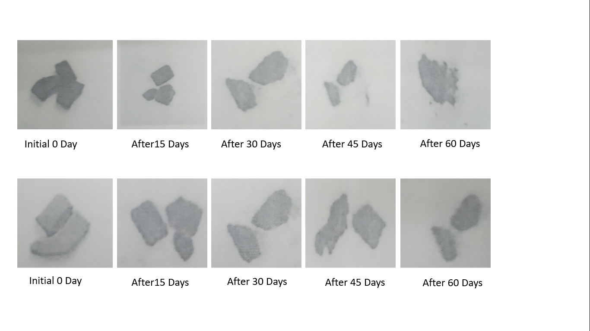

**Fig. 1** Pictorial views of biodegradation of DRB molded sheets



**Fig. 2** Biodegradability stages and time required for degradation of DRB molded

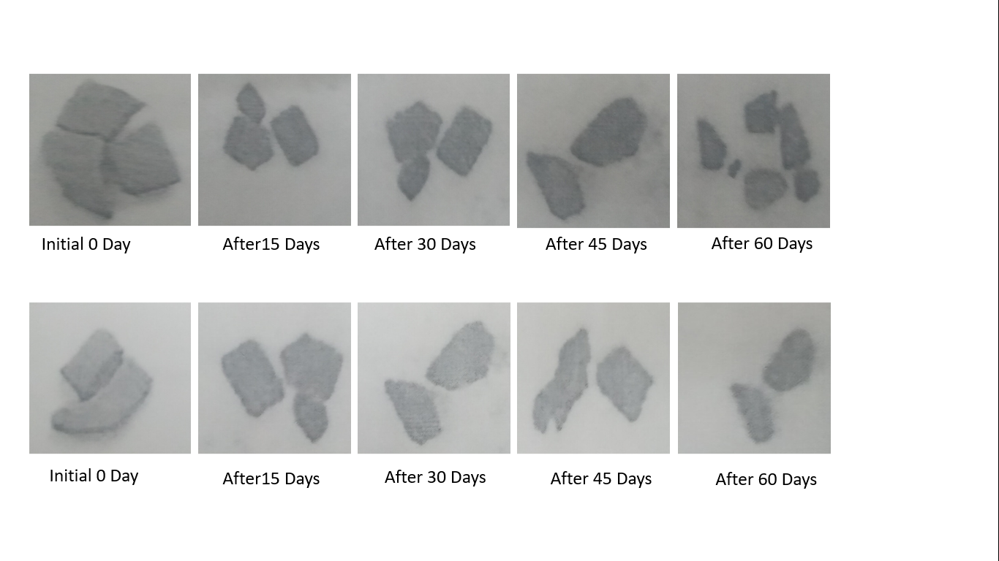

**Fig. 3** Biodegradability stages and time required for degradation of DRB molded sample having G/P ration of 0.2 which was degraded after 60 days

**Degradation of sample with 0.3 (G/P ratio) at 180°C**

These pictures 3. Showed the biodegradability stages and time required for degradation of DRB molded sample having G/P ratio of 0.3 which was degraded after 60 days of planting. The results of comparison of degradation between molded samples 0.4 molded at 170 C and 180°Cfor 40 min. showed that, the degradation of sample 0.3 molded at 180 C for 40 min was slightly fast than sample 0.3 molded at 170 C for 40 min.

**Degradation of sample with 0.4 (G/P ratio)**

These pictures 4 showed the biodegradability stages and time required for degradation of DRB molded sample having G/P ratio 0.4. It was completely degraded in 45days of planting in the soil. Degradation stages of 0.4 (G/P ratio) sample was gradually increased as number of days increased.

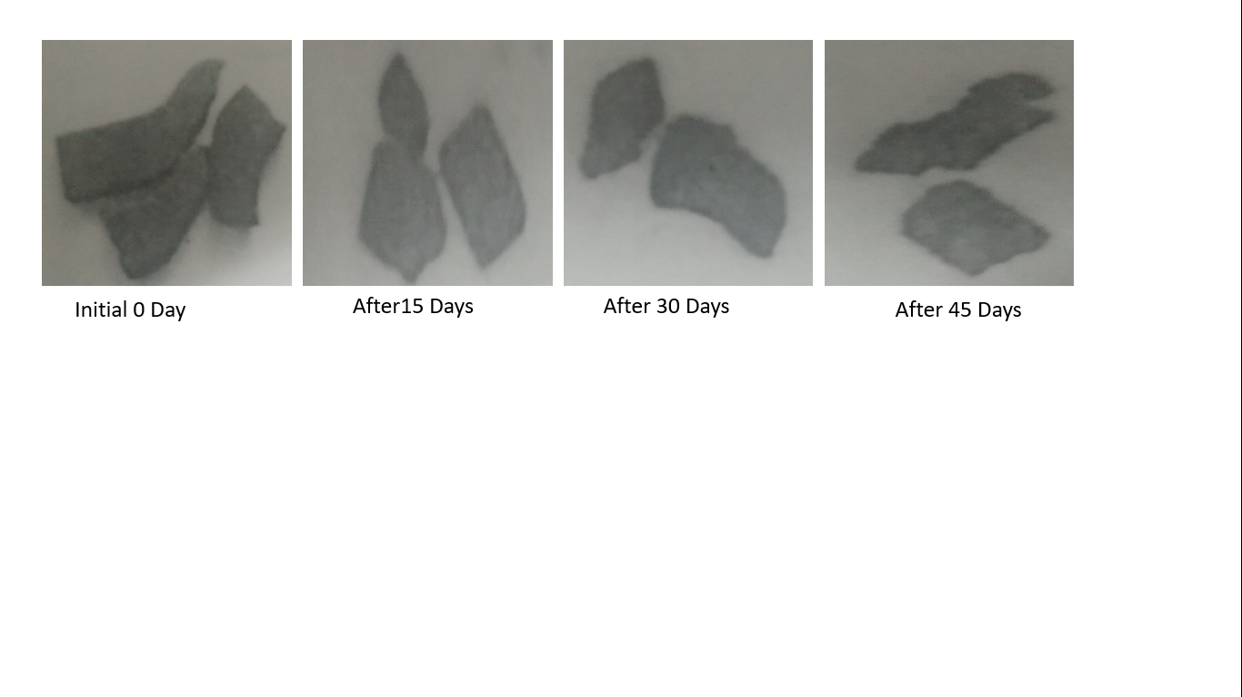

**Fig. 4** Showed the biodegradability stages and time required for degradation of DRB molded sample having G/P ratio of 0.2 which was degraded after 60 days of planting.

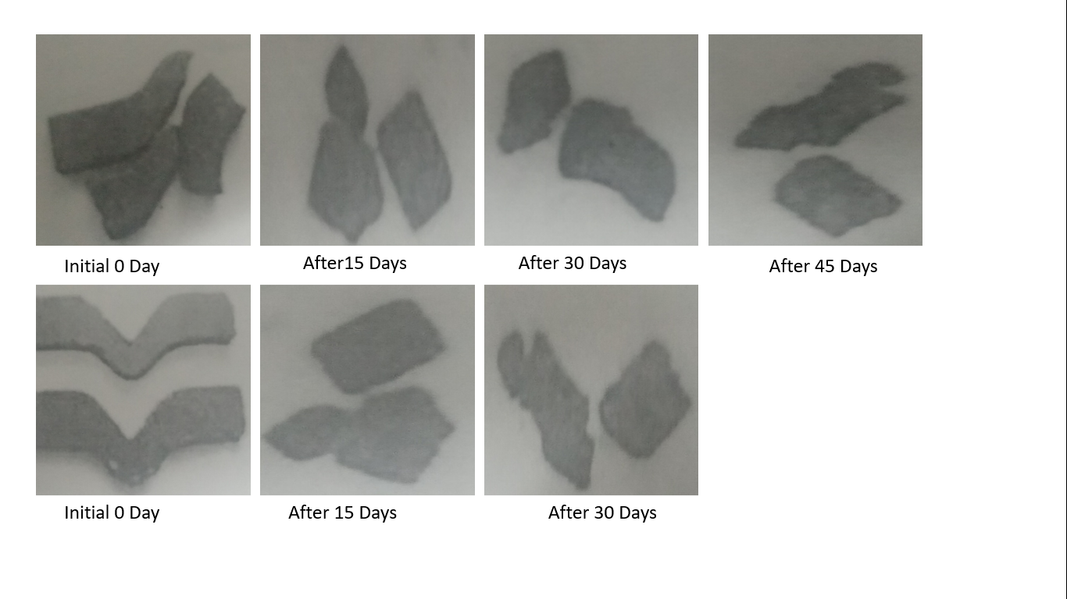

**Fig. 5** Showed the biodegradability stages and time required for degradation of DRB molded sample having G/P ratio of 0.4 it was completely degraded in 45 days of planting in the soil.

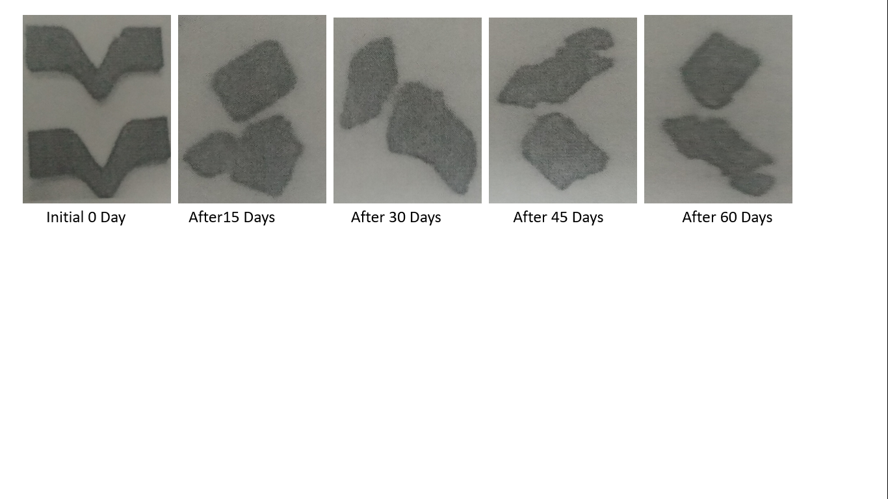

**Fig. 6** Showed the biodegradability stages and time required for degradation of DRB molded sample having G/P ratio of 0.2which was degraded in 75 days of planting in the soil.

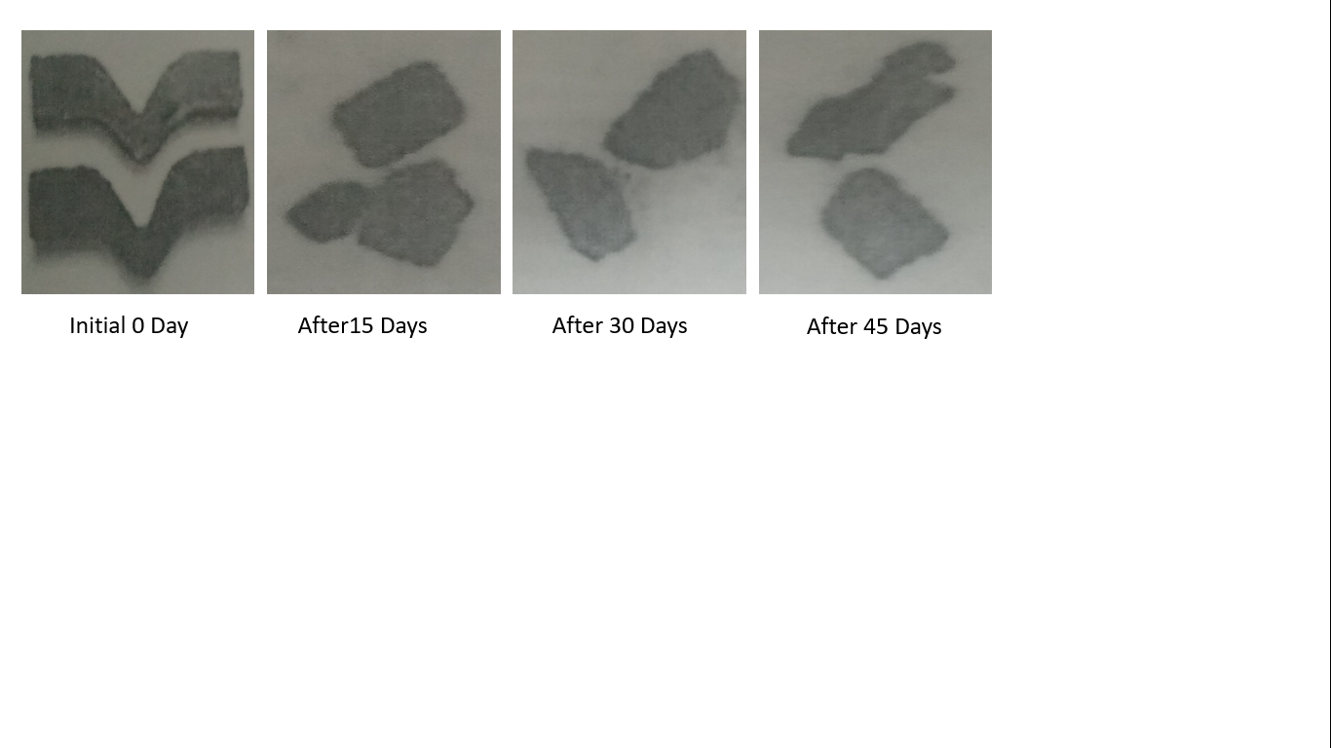

**Fig. 7** Showed the biodegradability stages and time required for degradation of DRB molded sample having G/P ratio of 0.6 which was good water holding and solubility but has a poor hardness was degraded in 60 days of planting in the soil.

**Degradation of sample with 0.5 (G/P ratio)**

These pictures 5 showed the biodegradability stages and time required for degradation of DRB molded sample having G/P ratio of 0.3 which was degraded in 75 days

**Degradation of sample with 0.6 (G/P ratio)**

These pictures 6 showed the biodegradability stages and time duration for degradation of DRB molded sample having G/P ratio of 0.6 which has good water holding and solubility but has poor hardness, was degraded in 60 days of planting in the soil.

**Conclusion**

In the present investigation on development of biodegradable sheets using extrusion and compression molding process, from deoiled rice bran, an alternative to starch-based polymers, it was observed that there was a significant change in all the physico-chemical, rheological and degradation characteristics of the samples with varied glycerol content. Protein solubility of deoiled rice bran increased with increased pH. The optimized barrel temperature and feed rate of twin-screw extruder for the formulation of pellets from deoiled rice bran were 140 C and 5 g/s, respectively. The most suitable molding temperature-time combination for the formation of molded sheets using hydraulic press molding machine were180°C and 40 min.

Water binding capacity, solubility as well as the texture of molded sheets was found to be more superior in 0.5 G/P ratio as compared to other ratios because other samples were low water resistant and broken easily. The 50% glycerol concentration gave better results in terms of rheological characteristics. Molded sheets prepared using 0.5 G/P ratio degraded in 45 days, control sample which was prepared at 180°C molding temperature 40 min. time and sample having G/P ratio 0.7 degraded in 60 days and other samples got degraded in 75 days. It was cleared from this research that the most significant conditions for preparation of molded sheets can be used as planting container, were barrel temperature 140°C, Flow rate 5 g/s, Molding temperature 180°C, Molding time 40min. and G/P ratio 0.5

Formulation of pellets with varying glycerol content could be extruded smoothly. With a decrease of glycerol content, injection-molding became more and more difficult. It is impossible to produce pots in large scale when the mass ratio of glycerol to polymer was lower than 0.5 in the given formulations. In the further work, novel plasticizer with higher efficiency than glycerol is needed for good process ability and low material cost.

**References**

1. Hernández-Barco, M., Sánchez-Martín, J., Corbacho-*Cuello, I., & Cañada-Cañada, F. (2021). Emotional performance of a low-cost eco-friendly project based learning methodology for science education: an approach in prospective teachers. Sustainability, 13(6), 3385.*
2. *Hilbert, L., Neves, E. G., Pugliese, F., Whitney, B. S., Shock, M., Veasey, E., & Iriarte, J. (2017). Evidence for mid-Holocene rice domestication in the Americas. Nature ecology & evolution, 1(11), 1693-1698.*
3. *Phalan, B., Bertzky, M., Butchart, S. H., Donald, P. F., Scharlemann, J. P., Stattersfield, A. J., & Balmford, A. (2013). Crop expansion and conservation priorities in tropical countries. PloS one, 8(1), e51759.*
4. *Ben Hassen, T., & El Bilali, H. (2022). Impacts of the Russia-Ukraine war on global food security: towards more sustainable and resilient food systems?. Foods, 11(15), 2301.*
5. *Huang, M., Li, X., Hu, L., Xiao, Z., Chen, J., & Cao, F. (2021). Comparing texture and digestion properties between white and brown rice of indica cultivars preferred by Chinese consumers. Scientific Reports, 11(1), 19054.*
6. *Borresen, E. C., & Ryan, E. P. (2014). Rice bran: a food ingredient with global public health opportunities. In Wheat and rice in disease prevention and health (pp. 301-310). Academic Press.*
7. *Markevičiūtė, Z., & Varžinskas, V. (2022). Plant-Origin Feedstock Applications in Fully Green Food Packaging: The Potential for Tree-Free Paper and Plant-Origin Bio-Plastics in the Baltic Sea Region. Sustainability, 14(12), 7393.*
8. *Tabasum, S., Younas, M., Zaeem, M. A., Majeed, I., Majeed, M., Noreen, A., ... & Zia, K. M. (2019). A review on blending of corn starch with natural and synthetic polymers, and inorganic nanoparticles with mathematical modeling. International journal of biological macromolecules, 122, 969-996.*
9. *Zhang, Y., Wang, B., Zhang, W., Xu, W., & Hu, Z. (2019). Effects and mechanism of dilute acid soaking with ultrasound pretreatment on rice bran protein extraction. Journal of Cereal Science, 87, 318-324.*
10. *Jung, S., Rickert, D. A., Deak, N. A., Aldin, E. D., Recknor, J., Johnson, L. A., & Murphy, P. A. (2003). Comparison of Kjeldahl and Dumas methods for determining protein contents of soybean products. Journal of the American Oil Chemists' Society, 80, 1169-1173.*
11. *Alemayehu, H. (2017). Product Development and Quality Characterization of Pulse-based Extruded Ready to Eat Snacks (Doctoral dissertation, Addis Ababa University Addis Ababa, Ethiopia).*
12. *Davis, M. T., Potter, C. B., & Walker, G. M. (2018). Downstream processing of a ternary amorphous solid dispersion: The impacts of spray drying and hot melt extrusion on powder flow, compression and dissolution. International journal of pharmaceutics, 544(1), 242-253.*
13. *Osen, R., Toelstede, S., Wild, F., Eisner, P., & Schweiggert-Weisz, U. (2014). High moisture extrusion cooking of pea protein isolates: Raw material characteristics, extruder responses, and texture properties. Journal of Food Engineering, 127, 67-74.*
14. *Moghal, M. M. R., Hossain, F., & Yamazaki, M. (2020). Action of antimicrobial peptides and cell-penetrating peptides on membrane potential revealed by the single GUV method. Biophysical Reviews, 12, 339-348.*
15. *Wever, G., & Eymar, E. (1997, May). Characterisation of the hydro physical and mechanical properties of pressed blocks for transplanting. In International Symposium on Growing Media and Hydroponics 481 (pp. 111-120).*
16. *Stevenson, F. J. (1983). Nitrogen—organic forms. Methods of Soil Analysis: Part 2 Chemical and Microbiological Properties, 9, 625-641.*